NDUSTRIA™ Electric High-Intensity Infrared Heaters
NEL-Series

Easy Buying and Online Ordering Guide
www.ndustria.com

Before you begin please note that our infrared heaters should be installed by a contractor qualified in the installation and service of HVAC equipment. These products require appropriate electrical service and safe placement. However, whether you are an end user or a contractor, we hope this guide will make ordering easier by helping you gather key data in a simple worksheet, which you’ll find below.

Once you’ve collected this information referenced in this buying guide, we realize that you may have additional questions about your specific space. We’re here to help! Our experts are standing by M-F 8:15 am – 4:45 pm EST for an online chat, which you can access from our website. Or, you can call 716-551-7900, or email info@ndustria.com to get answers to your questions or other assistance in determining the best product to order.

The NEL-series infrared heaters are intended for indoor or outdoor spot heating in commercial/industrial applications, or for outdoor residential applications. The heaters can be wall or ceiling mounted using the supplied brackets while maintaining appropriate clearances.

Step 1: What measurements are needed to determine which size heater or how many you may need?

There are three key measurements you will want to collect

1 Heater mounting height. The NEL-series heaters are required to be installed a minimum of 79” above the finished floor to avoid coming into contact with the heater. When measuring the height of your space, be sure that you have a minimum of 79” below the heater and 18” above the heater to maintain proper clearances.

(insert side drawing of heater used in clearance to combustibles chart showing 18” above the heater and 79” below the heater)

2 Total length and width of the area you wish to heat.

3 Survey your space to determine: Are there any clearances issues for structures, features, or objects that would interfere above, below, or to the sides of the unit? You will see minimum clearances recommendations in the installation and operation manual.

Step 2: You’ve measured. Now, let’s talk about heat coverage.

The NEL-series heaters focuses heat in the area the heater is directed at. The approximate heat coverage area will vary depending on which of the 3 different sizes you choose.
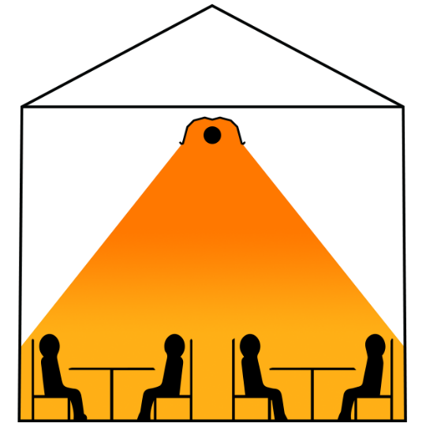
(replace these images with the 3 heat coverage images).

Heater Spacing
For applications that require multiple heaters, understanding how far apart to space the heaters is simple. Follow these general guidelines:

It is ideal to space the heaters apart so that the heat patterns shown in Step 2 touch each other from side to side. (e.g. The approximate width of the heat coverage for our 1500W heater is 6’. Therefore, the heaters should be placed approximately 6’ apart.)

Step 4: You have multiple options for how you mount the heater

The heater can be mounted on a ceiling and directed straight down, or can be wall mounted and angled anywhere between 38° to 70°. The supplied wall brackets provide this flexibility. However, it is important to remember to maintain 18” of clearance above the heater. It some cases to maintain the 18” clearance, extension brackets (not supplied) may be required.

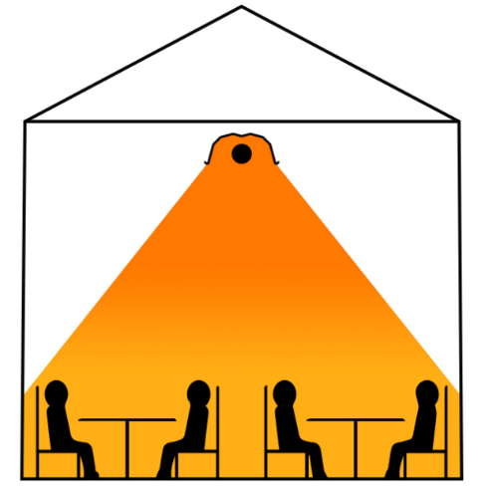
Tilt Level
(create an image similar to the one above by putting electric heater in place of the low intensity)

General tips and recommendations:
There are two elements that warrant consideration and possibly a conversation with your installer before you order if you have any concerns.

- You’ll want to identify available heater mounting points and access to electrical supply.
- Make sure you follow and plan for the specified clearance to combustibles listed in the installation manual.

____
Worksheet

Electrical Supply?
Overhead/mounting height
(Note: maintain appropriate clearances to combustibles as specified in the installation and operation manual)
Heated space (length X width)
Any clearances issues?
How many units/unit size?

Sample worksheet, filled out, ready to use for ordering:

Electrical Supply? | 120 VAC, 25 Amps
Overhead/mounting height  (Note: maintain appropriate clearances to combustibles as specified in the installation and operation manual) | 8’ from floor to ceiling
Heated space (length X width) | 8’ X 12’
Any clearances issues? | No
How many units/unite size? | Quantity 2 of model NEL-15 (1500W)

