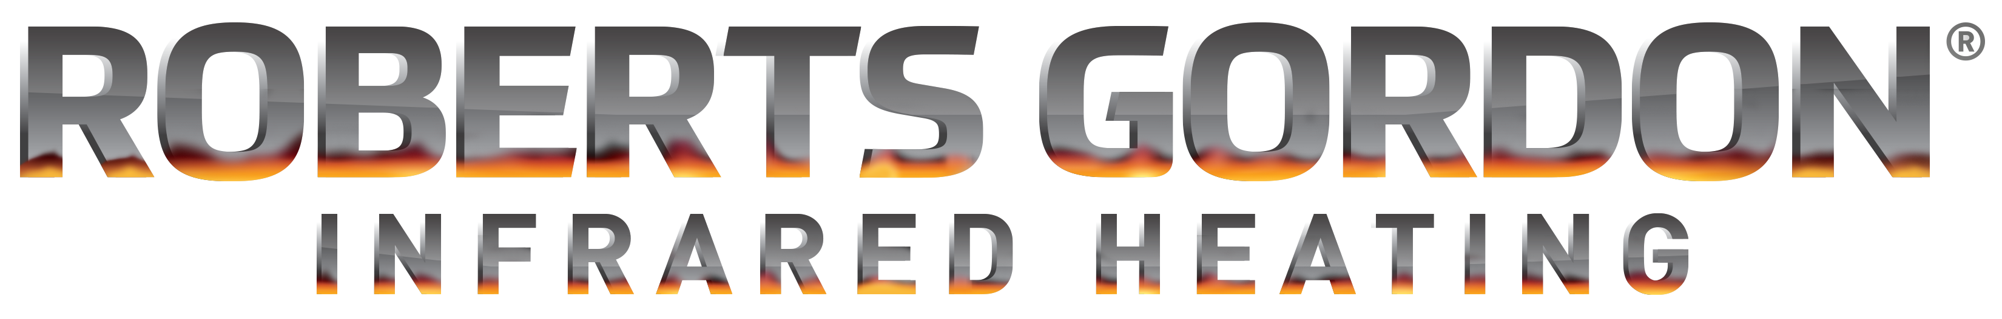
CARIBE® INFRARED RADIANT HEATERS
PRODUCT SPECIFICATIONS

The completely factory assembled, balanced-flue heating system supplied shall be design certified by the American Gas Association and the Canadian Gas Association. The systems shall be approved for both residential and commercial applications.

Burner and Burner Controls

1. Burners shall be capable of firing with one of the fuel options as specified on the purchase documents:
Natural Gas or LP.

2. Burners shall be supplied to fire at any one of the input firing rates as specified:

CGTH-30 30,000 Bth/h.
CGTH-40 40,000 Btu/h
CGTH-50 50,000 Btu/h.

3. Burners shall be equipped with a system control that combines gas flow control and electronic burner ignition sequencing functions into a single unit. This control shall provide all gas ignition safety functions by controlling gas flow, ignition source and the combustion air blower. The control shall also monitor the air-proving switch to assure proper burner operation. Such control shall provide pre-purge and timed trial for ignition with three ignition trials and auto reset from lockout.

4. Power supplied to each burner shall be 120 volts AC, 60Hz, single phase. Burners shall be rated for 1.0 Amp.

5. Burner shall be supplied with thermal overload protection for the blower. The blower shall also be supplied with an integral cooling fan, balanced air rotor, combustion air proving safety pressure switch, and viewing window for flame observation.

6. Burners are controlled with 24 volts AC low voltage thermostats.

7. Gas supply to the burners shall be as follows:
3/8” NPT
Natural Gas: 5.0”W.C. Min, 14.0”W.C. Max
LP Gas: 11.0”W.C. Min, 14.0”W.C. Max

Heat Exchanger

- Single piece radiant u-tube shall be 3” (7.5 cm) O.D., Heat Treated Aluminized steel tube X 16 gauge wall with an emissivity factor of 0.80 or greater.

- Reflector to be of aluminum material (Type 1100 H18 series) and designed to direct all radiant output below horizontal centerline of radiant tube. Reflectors shall be certified for 0° or 45° mounting.

- Reflectors shall have end caps to prevent heat loss due to convective loss.

- Steel turbulators are to be used as specified for even heat distribution and increased efficiency.

- Heater to be concentric vented according to manufacturer’s instructions providing for single penetration of the building (wall/roof).

- The heat exchanger/user protection shall be provided by isolated stainless steel protective grill.

Balanced Flue

- Each heater shall be supplied with 5’ (1.5 m) long balanced (concentric) flue.

2. Concentric flue combines a 3” (7.5 cm) O.D. exhaust pipe inside a 5” (12.5 cm) O.D. fresh air intake pipe, requiring only one building penetration for outside combustion air supply and exhaust.

